he process of emmetropization directs the eyes of
infants to grow in a highly coordinated fashion toward
an ideal refractive state.

a.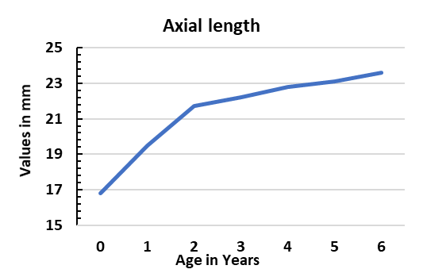
b.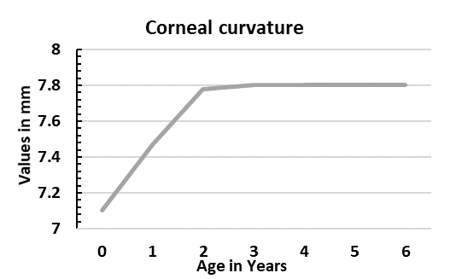
c.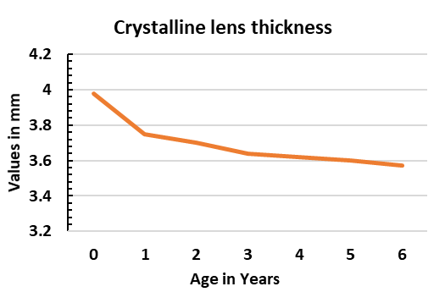
Figure 1: Graphs representing the growth curves for (a) axial length⁴, corneal curvature³, and the crystalline lens⁵ in children.

